1. Commercial Proposal for
Reference Access and Interconnection Offer Sub Annex C-FA 20 Network-to-Network Interface
Table of Contents

1 General 3
2 Definitions 4
3 Network-to-Network (NNI) Service 5
4 Terms and Conditions 10
5 Database 13
6 Ordering and Delivery 14
7 Prices 15
8 Fault Management 16
9 Forecasts 17

General
  - This Sub Annex sets out the Omantel offer for Network-to-Network Interface.

Definitions
  - The definitions in Annex L shall apply to this Sub Annex in addition to the following definitions:
    - Contract Term – the contract period of the Service provisioning starting from the Service provisioning date.
    - Service – Network-to-Network Interface

Network-to-Network (NNI) Service
  - Omantel through this Service enables the Requesting party to establish a Network-to-Network interface (NNI) with Omantel for the purpose of connecting to Omantel’s networks. A NNI is a physical interface that connects two networks and defines the traffic flow and management processes for individual customers that are being serviced by the two entities
  - Request for this Service shall be initiated by the Requesting Party. Different NNIs are needed to support Layer 2 and Layer 3 traffic, and therefore the Requesting Party shall clearly specify the type of NNI (Layer 2 or Layer 3 NNI) in its request.
  - The descriptions of Layer 2 NNI and Layer 3 NNI services are similar. Hence the description below is generally applicable to both the types.
  - The NNI service has two parts:
    - Establishing the NNI Service:
      - The Requesting Party shall extend its network up to the Zero manhole at the premises of Omantel Fixed POI.
      - Omantel shall then connect the Requesting Party’s network to its (Requesting Party’s) PE router inside the premises of Fixed POI. The charges for connecting the Requesting Party’s network to the Requesting Party’s PE router are not included as part of this service. The Requesting Party has to order appropriate RAIO service for this connectivity.
      - The Requesting Party’s PE router and Omantel’s PE router shall be connected to establish the NNI service. Omantel PE router may be deployed at Omantel Fixed PoIs if requested. Nevertheless, in case of unfeasibility, the Requesting Party may order connectivity between Omantel Fixed PoI and Omantel PE router location using the appropriate RAIO services (C-FA 10 and C-FA 11).
      - The diagrams below are generic representations of the NNI service. Actual setup may vary depending on the locations of the fixed POIs and of the PE routers. During technical feasibility, parties shall agree on the requirements that Omantel can fulfill as part of the order.

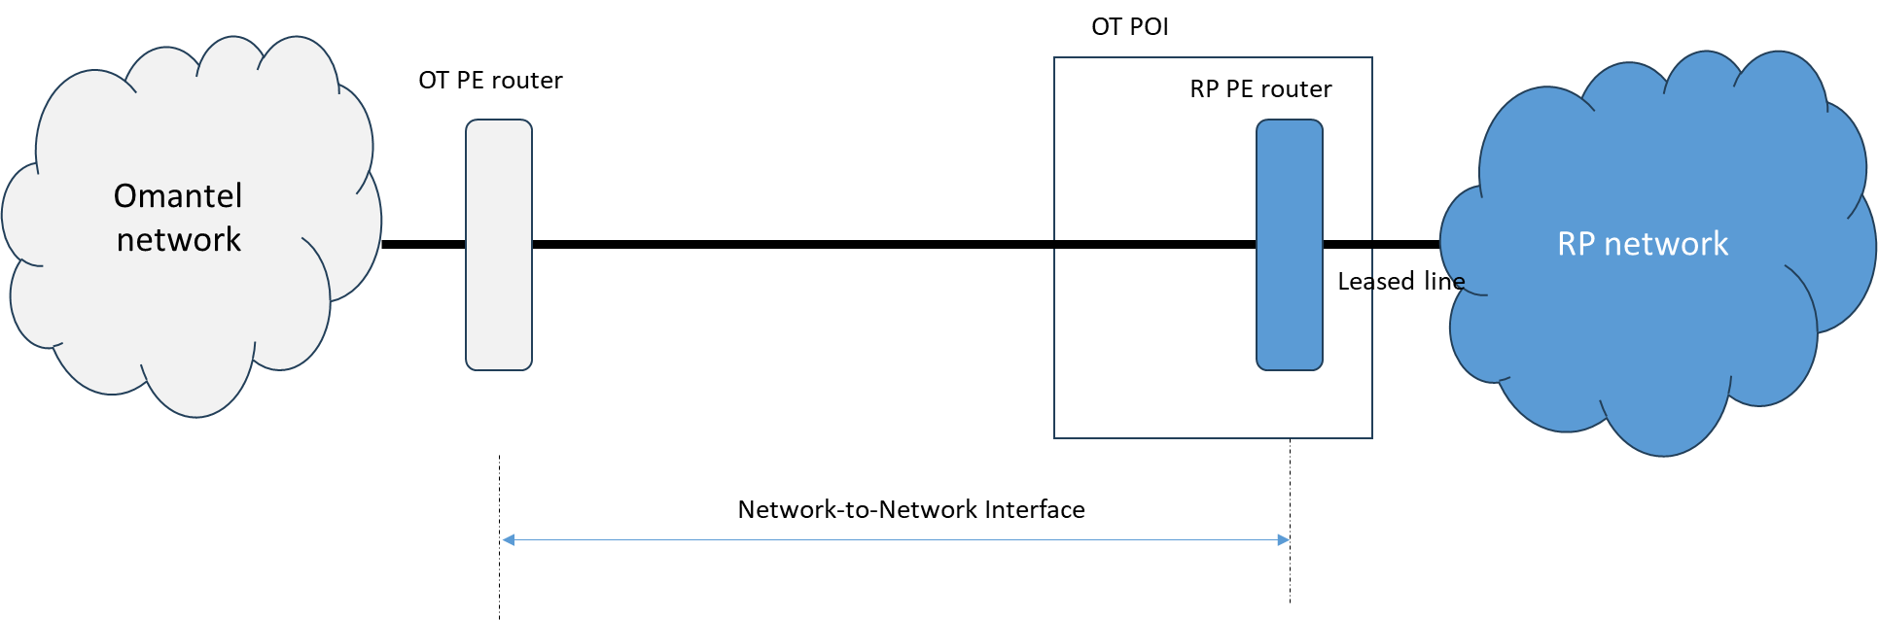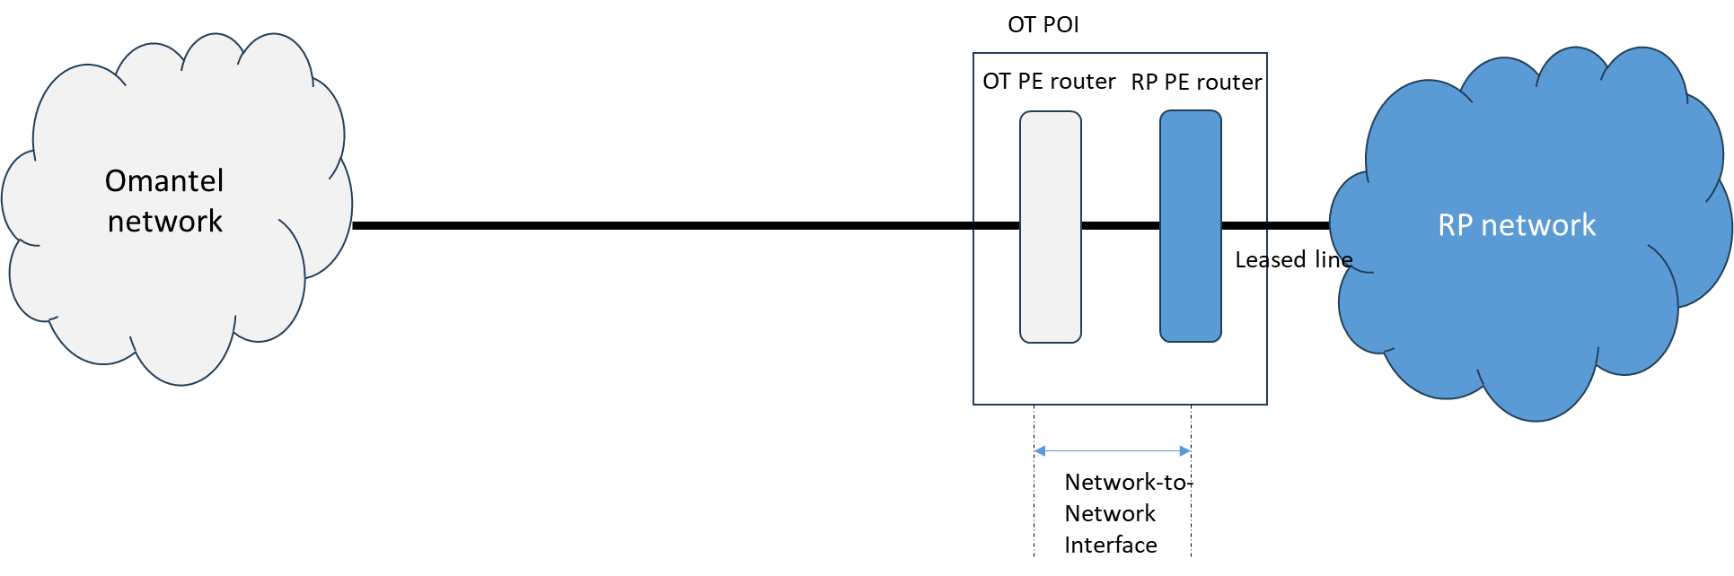
Figure 1: Generic representations of NNI service
      - In case of L3 NNI, Omantel uses Inter-AS L3 VPN Option A based on RFC4364 Section 10a first. In Option A interconnect arrangement, a PE (ASBR PE) router in one AS attaches to a PE router in the AS of the partner network. The physical interface between the two PE routers will be configured with sub-interface. This sub-interface will be assigned to a VPN VRF which is associated with an individual customer whose routes need to be passed between the partner Autonomous Systems Number. The PE routers will treat each other as CE router over each VRF/Sub-interface and use EBGP protocol to mutually distribute unlabeled IPv4 addresses. Option A Interconnect is also called back to back VRF method at the AS border routers.
      - The NNI Service and the subsequent upgrades are offered at the following bandwidths in multiples of:
- 2 Mbit/s (E1)
- 155 Mbit/s (STM1)
- 1 Gbits/s
- 10 Gbits/s
- 100 Gbits/s
      - Omantel offers the possibility of NNI link protection by two separate interface cards on the Omantel NNI peering router towards the Partner router. There will be additional charges to support this.
      - At least two NNIs of the same type shall be established between Omantel and the Requesting Party at two different locations; i.e if the Requesting Party requires Layer 2 NNI, then it has to request two Layer 2 NNIs.
    - Setting up of individual customer traffic over the NNI:
      - After the NNI is established, the Requesting Party can request to set up the routing of its customers through this NNI.
      - Charges relating to this service are per customer.
      - Each customer will utilize a sub-interface
      - For each customer, the following process is followed:
- Omantel Solution team will analyze the requirement and verify the technical feasibility.
- Omantel will create a VLAN and assign an id.
- Omantel will design the end-to-end solution that will include all technical details, resources needed, and timelines to deliver.
- Once the design is agreed upon, the Requesting Party shall send a signed order form.
- Omantel Provisioning team will prepare the script and Change Request to deploy the configuration on NNI IGW and IPCore nodes and will perform staging/pre-configuration activity.
- Omantel shall complete the configuration in IGW-NNI /IPCore/ as per Customer Work Order, during which below tasks will be performed.
- Configuration of the required sub interfaces with the appropriate network virtualization method
- Assignment of the required Virtual Routing and Forwarding (VRF) instances.
- Assignment of the required IP addresses
- Stability testing of interfaces for 24 hours.
- Configuration of EBGP protocols on the NNI sub interface
- Applying the appropriate EBGP, Import and Export route policies
- Applying the required rate-limits on the sub interface corresponding the values in the order forms
- Enabling the appropriate MP-BGP import and export policies within the newly configured VRF
- Verifying the correct state of routes on the corresponding VRFs that had been configured on other PEs within the Omantel network
- Verifying end to end connectivity from the Customer CPE on the Omantel Network to the CPE that is connected to the partner network.
- The service once configured on NNI would be tested as per Standards.
  - Where certain site preparation is to be carried out by Omantel, the Requesting Party shall pay all the reasonable costs incurred by Omantel in carrying out this activity plus a markup percentage specified in Annex M.
  - If the Requesting Party requires Omantel to perform additional tasks, Omantel may offer to perform those additional tasks, subject to feasibility. The Requesting Party should request in writing for Omantel to perform such additional tasks. In such cases, Omantel will charge the Requesting Party on a cost plus a markup percentage specified in Annex M.
  - Omantel shall inform the Requesting Party about the result of the technical feasibility and availability. In case it is not possible to offer this Service at the requested location, Omantel may propose an alternative solution.

Terms and Conditions
  - Service Provisioning:
    - The Service provision shall be subject to a technical feasibility. If the result of the feasibility study is that the order shall be rejected, Omantel will justify that conclusion and share the reasons with the Requesting Party in writing..
    - The Requesting Party shall not assign, transfer, lease, resell, or share their interest in the NNI Service irrespective of the nature of their relationship. Subleasing or installing the equipment of any other third party will be considered as breach to this Agreement.
    - Omantel will be responsible to maintain the NNI and shall ensure that the NNI Service offered to the Requesting Party are at the same level of quality as those to Omantel’s own Customers subject to sufficient capacity on the NNI link requested by the Requesting Party.
  - The Requesting Party Responsibility:
    - The Requesting Party shall request the NNI Service specifying the details of the request.
    - The Requesting Party shall ensure sufficient capacity on the NNI link.
    - The Requesting party may request the transmission link to connect its network to its PE router. The charges for the transmission link are separate and are not included in this service.
    - The Requesting Party shall request the setting up of the customer on the NNI for each of its customers.
    - The Requesting Party shall pay Omantel the charges specified in Clause 7 below.
  - Change request to existing NNI
    - Upgrade orders for the NNI bandwidth are placed according to order procedures in Clause 6 of this Sub Annex.
    - The monthly fees for the increased bandwidth will be applicable from the date that the upgrade is performed.
    - A new Contract Term will be applicable for the upgraded link and the existing Contract Term will be cancelled without any early termination charges.
    - Changes other than upgrading the bandwidth shall be considered as a termination of the Service and an Order of a new one.
  - Contract Terms and Termination:
    - Establishing the NNI Service:
      - The minimum Contract Term of the Establishing the NNI Service is five (5) years.
      - If either Party wishes to terminate the contract after the completion of the Contract Term, it shall inform the other Party, in writing, three (3) months before the completion of Contract Term, of its intent to terminate the Contract. The Requesting Party shall be responsible of the consequences if it terminated the Service with active Customer on his network.
      - If no notice is provided at least three (3) months before the completion of Contract, the Contract will be automatically renewed on monthly basis.
    - Setting up of individual customers through the NNI:
      - The minimum Contract Term is one (1) year.
      - If either Party wishes to terminate the contract after the completion of the Contract Term, it shall inform the other party, in writing, one (1) month before the completion of Contract Term of its intent to terminate the Contract.
      - If no notice is provided at least one (1) month before the completion of Contract, the Contract will be automatically renewed on monthly basis.
    - Omantel has the right to suspend the Service in accordance with Clause 17 of the Main Agreement in case the Requesting Party is in breach of its obligation under this Agreement.
    - Termination of the Service by the Requesting Party before the expiration of the Contract Term is subject to early Termination Fee equal to the charges of the remaining period of the Contract Term. Once the initial term has concluded, and the agreement has been renewed, no Early Termination fees shall be applicable. If either Party wishes to terminate the contract, it shall inform the other party in writing three (3) months in advance of its intent to terminate the Contract. The Providing Party shall not terminate the Contract without the prior approval of the TRA. If no such notice is provided, the Contract will be automatically renewed for the same Contract Term.
    - The termination will be in accordance with the procedures in Annex H.

Database
  - Omantel will keep updated a database consisting of all customers that have established a NNI with Omantel. The database will consist of at least the following parameters:
- Operator Name
- NNI bandwidth
- NNI location
- order date
- delivery date
- installation fee
- monthly fee
- List of customers configured

Ordering and Delivery
  - Ordering and delivery is handled according to Annex H in addition to the following.
  - Establishing the NNI:
    - Omantel shall target a delivery time of 75 Working Days subject to feasibility, cooperation of the Requesting Party and any other third Party and that there will be no delays caused by factors outside Omantel’s control such as, for example, due to the delay arising from the involvement of governmental entities.
    - Omantel shall inform the Requesting Party once the NNI is established. The Requesting Party shall test the link within 3 Working Days and return back to Omantel during the same period for any issues. In case the Requesting Party does not report issues within (3) days, Omantel shall start charging the Requesting Party from the date the NNI was established.
    - If Omantel rejects the request, Omantel shall inform the Requesting Party on the reasons, which shall be objectively justifiable such as technical feasibility problems.
  - Setting up individual customer traffic through the NNI:
    - Omantel shall target a delivery time of 30 Working Days subject to feasibility, cooperation of the Requesting Party and any other third Party and that there will be no delays caused by factors outside Omantel’s control such as, for example, due to the delay arising from the involvement of governmental entities.
    - Omantel shall inform the Requesting Party once the customer traffic is setup through the NNI. The Requesting Party shall test the link within 3 Working Days and return back to Omantel during the same period for any issues. In case the Requesting Party does not report issues within (3) Working days, Omantel shall start charging the Requesting Party from the date of setup of customer traffic.
    - If Omantel rejects the request, Omantel shall inform the Requesting Party on the reasons, which shall be objectively justifiable such as technical feasibility problems.

Prices
  - The up to date prices for the Services can be found in Annex M of the Reference Offer.
  - The cost of additional product features, specialized billing, systems and/or network interfaces, non-standard connectivity and associated configuration, integration and testing are not included in the published tariffs. Such cases will be dealt with on a case-by-case basis against mutual agreed timelines and charges. Omantel shall inform the TRA accordingly, and obtain the necessary approvals from it. For the avoidance of doubt, the cost of integration and testing of standard orders is included in the published NRC/set-up fee for the corresponding service and any such charges shall apply to items that could not reasonably be foreseen or in respect to special requirements from the Requesting Party during the provisioning of the services.Any additional costs for repair, replacement or maintenance shall be borne by the Requesting Party as per Annex M. Omantel shall provide all the documentation at reasonable degree of acceptance to support the work carried out by Omantel or by its contractors.

Fault Management
  - Fault Management is handled according to Annex H in additional to the following Services.
  - The Requesting Party shall ensure to carry out the initial tests in respect of any fault in customer connection in order to validate that the fault is not from the Requesting Party Network. In case the fault is not at the Requesting Party Network, the Requesting Party shall make available all reasonable and complete test details when reporting the fault to Omantel.
  - In case no Fault found from Omantel’s side, Omantel shall charge the Requesting Party a Fault handling fee.

Forecasts
  - Forecasting shall be handled according to Annex F.

