1. Commercial Proposal for
Reference Access and Interconnection Offer Sub Annex C-FA 19 Virtual Unbundled Local Access
Table of Contents

1 General 3
2 Definition 4
3 Virtual Unbundled Local Access (VULA) 5
4 Terms and Conditions 10
5 Database 15
6 Ordering and Delivery 16
7 Prices 18
8 Fault Management 19
9 Forecasts 20

General
  - This Sub Annex sets out the Omantel offer for Virtual Unbundled Local Access (VULA) Service.

Definition
  - The definitions in Annex L shall apply to this Sub Annex in addition to the following definitions:
    - Contract Term – the contract period of the Service provisioning starting from the Service provisioning date.

Virtual Unbundled Local Access (VULA)
  - The Service has two parts:
  - Establishing the VULA NNI
    - The Requesting Party should first request to establish VULA NNI with Omantel to be able to request VULA connectivity for its users on Omantel’s network.
    - The Requesting Party shall extend its network up to the Zero manhole at the premises of Omantel Fixed POI.
    - Omantel shall then connect the Requesting Party’s network to its (Requesting Party’s) Edge router inside the premises of Fixed POI. The charges for connecting the Requesting Party’s network to the Requesting Party’s Edge router are not included as part of this service. The Requesting Party has to order appropriate RAIO service (C-FA 10 and C-FA 11) for this connectivity.
    - The Requesting Party’s Edge router and Omantel’s Edge router shall be connected to establish the VULA NNI. For the avoidance of doubt, Omantel Edge router may not be deployed at Omantel Fixed POIs. The Requesting Party shall order the connectivity between Omantel Fixed POI to Omantel Edge router location using the appropriate RAIO services (C-FA 10 and C-FA 11).
    - The diagrams below are generic representations of VULA NNIs. Actual setup may vary depending on the locations of the fixed POIs and of the edge routers. During technical feasibility, parties shall agree on the requirements that Omantel can fulfill as part of the order.
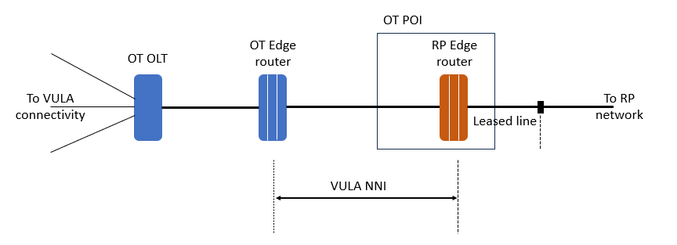
Figure 1: Generic representation of VULA NNI with the Omantel edge router not located in the Omantel POI

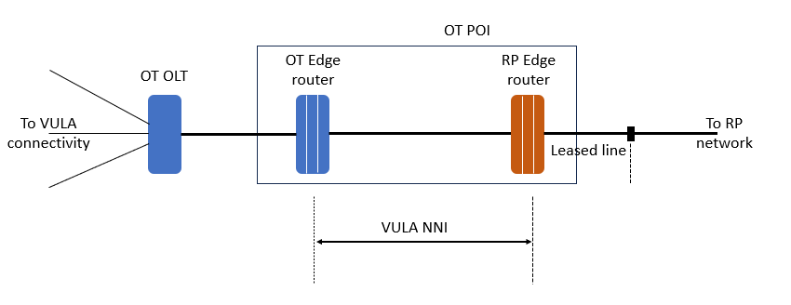
Figure 2: Generic representation of VULA NNI with the Omantel edge router located in the Omantel POI

    - This Service and the subsequent upgrades are offered at the following bandwidths in multiples of:
- 2 Mbit/s (E1)
- 155 Mbit/s (STM1)
- 1 Gbits/s
- 10 Gbits/s

    - Omantel offers the possibility of NNI link protection by two separate interface cards. There will be additional charges to support this.
    - At least two VULA NNIs shall be established between Omantel and the Requesting Party at two different locations.
  - VULA connectivity
    - Homes Passed means a premise which a Requesting Party has capability to connect to via an FTTH/FTTB network in a service area. Typically new service activation to such Premise will require the installation and/or connection of a drop cable from the home passed point (e.g. fibre-pedestal, manhole, chamber, utility-pole) to the Customer Access Point, and the installation of an Optical Network Terminal (ONT) inside the Premise. Such Homes Passed excludes Premises that cannot be connected without further installation of substantial fibre plant such as feeder and distribution cables (fibre) to reach the area in which a potential new Customer is located.
    - At the Homes Passed, Omantel shall present a Fast Ethernet cable connection from an Ethernet port of a Modem through which the Requesting Party can access and manage the User services.
    - Unless already installed, an Omantel technician or a technician working on behalf of Omantel, will visit the User’s premises to install a VULA Connection to and inside the premises. This consists of a secondary cable running from the distribution box outside the Premises to the Modem installed inside the Premises. The technician will install the modem inside the Premises, power the modem, test the setup and record the test results.
    - The modem represents Omantel’s network and the service demarcation point. The Requesting Party is responsible for the installation of devices beyond the modem. These could consist of the Requesting Party Wifi router as well as the User’s computer or other devices. There will be one Ethernet port per modem.
    - The location where the modem will be installed will be discussed with the end customer. However, the length of the cable from the entry point on the premises to the modem must be less than 10 meters. Omantel may opt to install longer lengths at an additional charge as set out in Annex M.
    - The final decision on where and how the cable and modem will be installed shall be at the discretion of the Technician. Upon completion of installation, the modem will be powered up and the Technician will run a test on the line to confirm that the VULA Connection is functioning properly.
    - The installation and testing of any Requesting Party routers and User devices beyond the modem are outside the scope of Omantel’s responsibility and the technician shall not be approached to connect and/or test any of the Requesting Party routers and User devices beyond the modem.
    - The diagram below is a generic representation of VULA connectivity. Actual setup may vary depending on the exchange and the customer premises. During technical feasibility, parties shall agree on the requirements that Omantel can fulfill as part of the order.

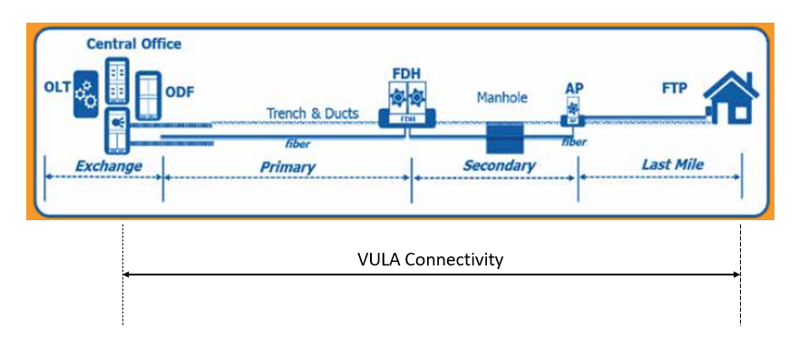
Figure 3: Generic representation of VULA connectivity

Terms and Conditions
  - Service Provisioning:
    - The Service provision shall be subject to a technical feasibility study. If the result of the feasibility study is that the order shall be rejected, Omantel will justify that conclusion and share the reasons with the Requesting Party in writing.. .
    - Omantel shall remain the owner of the Service. The Requesting Party shall not assign, transfer, lease, sell, resell or share their interest with any Third Party Operator irrespective of the nature of their relationship. Subleasing or installing the equipment of any other third party will be considered as breach to this Agreement.
    - Omantel will be responsible to maintain the NNI and shall ensure that the VULA connectivity offered to the Requesting Party are at the same level of quality as those to Omantel’s own Customers subject to sufficient capacity on the NNI link requested by the Requesting Party.
    - For Establishing the VULA NNI
      - The Requesting party shall request the transmission link to connect its network to its Edge router. The charges for the transmission link are separate and are not included in this service.
      - The Requesting Party shall collocate its Edge router at the Fixed POI of Omantel. The charges for co-location and other ancillary services are separate and are not included in this Service
    - For VULA connectivity
      - The VULA connectivity service will be offered in locations where Omantel has connectivity to Customer premises and it is subject to resources availability.
      - If the end customer is already an Omantel customer, then Omantel shall offer the VULA service to the Requesting Party if that customer has paid in full the outstanding undisputed dues for this Service acquired from Omantel. Omantel may refuse to provide such a Service where the Customer has any outstanding undisputed amount. However, for the avoidance of doubt, even if Omantel exercises its discretion to provide the Service to the Requesting Party for that end Customer, this is without prejudice to its right to pursue a claim for the amount due from the end Customer.
      - If the end customer is already connected to any other Licensee, the request will be denied unless the Requesting Party provides Omantel with:

a verifiable termination notice from the user to its previous provider,

a No Objection Certificate (NOC) from the previous provider.
      - The NOC from a provider shall be considered as notice for termination, and based on this Omantel shall issue the invoice for early termination, if any, to that provider.
      - The service can only be provided to “Homes Passed” where Omantel has its network available and is subject to passing the technical feasibility check at the installation address. If the end-user installation address is already on the network, Omantel will fix an installation appointment with the end customer.
      - Omantel shall carry out the installation, testing, and perform the acceptance tests.
      - Once the acceptance test is completed, Omantel will inform the Requesting Party and handover the VULA connectivity.
      - One premise can be connected to only one operator.
      - Omantel shall not be responsible for any work within the boundary of the Customer’s premises.
      - Omantel shall be responsible for the quality-of-service metrics applicable on the segments of VULA service, offered by the Requesting Party to the Customer, that are within Omantel’s purview and demarcation points that includes but not limited to latency, jitter, congestion on the interconnect ports, etc.
      - Any Service that will be provided by the Requesting Party shall be based on the condition of the local loop. Omantel shall not modify its network to provide a higher bandwidth beyond or above the prequalified capacity of the local loop.
  - Omantel shall ensure that the Services offered to the Requesting Party are at the same level of quality as those to Omantel’s own Customers.
  - Where certain site preparation is to be carried out by Omantel, the Requesting Party shall pay all the reasonable costs incurred by Omantel in carrying out this activity plus a markup percentage specified in Annex M.
  - If the Requesting Party requires Omantel to perform additional tasks, Omantel may offer to perform those additional tasks, subject to feasibility. The Requesting Party should request in writing for Omantel to perform such additional tasks. In such cases, Omantel will charge the Requesting Party on a cost plus a markup percentage specified in Annex M.
  - The Requesting Party’s Responsibility:
    - The Requesting Party shall first request Omantel to establish the VULA NNI before requesting the VULA connectivity to individual customers.
    - The Requesting Party shall pay Omantel the charges specified in Clause 7 below.
    - The Requesting Party shall ensure sufficient capacity on the VULA NNI.
    - For each VULA connectivity, the Requesting Party shall submit with its VULA Request a copy of the Customer application form duly completed and signed by the Customer. The Request shall contain all necessary information about the Customer including but not limited to, the Customer details, the connectivity points and his connectivity requirement.
    - The Requesting Party shall be responsible for availability and quality of the Service offered to its Customer.
    - The Requesting Party shall be responsible to invoice and collect the outstanding dues from its Customers.
    - The Requesting Party shall pay Omantel the charges specified in Clause 7 below even if the Customer has not paid his dues to the Requesting Party.
    - The Requesting Party shall set up a call center to address all complaints from his Customer.
    - The Requesting Party shall request Patching service separately along with each VULA connectivity request.
  - Change request
    - Change request to the VULA NNI
      - Upgrade orders for the VULA NNI bandwidth are placed according to order procedures in Clause 6 of this Sub Annex.
      - The monthly fees for the increased bandwidth will be applicable from the date that the upgrade is performed.
      - A new Contract Term will be applicable for the upgraded link and the existing Contract Term will be cancelled without any early termination charges.
      - Changes other than upgrading the bandwidth shall be considered as a termination of the Service and an Order of a new one.
    - Changing Location of VULA connectivity
      - All changes to the location of the Local Loop will be considered as a termination of the VULA connectivity service and an order of a new one.
  - Contract Terms and Termination:
    - Establishing the VULA NNI:
      - The minimum Contract Term is three (3) years.
      - If either Party wishes to terminate the contract after the completion of the Contract Term, it shall inform the other Party, in writing, three (3) months before the completion of Contract Term, of its intent to terminate the Contract. The Requesting Party shall be responsible of the consequences if it terminated the Service with active Customer on his network.
      - If no notice is provided at least three (3) months before the completion of Contract, the Contract will be automatically renewed for the same Contract Term.
    - VULA Connectivity:
      - The minimum Contract Term of the VULA connectivity is one (1) year.
      - If either Party wishes to terminate the contract after the completion of the Contract Term, it shall inform the other party, in writing, one (1) month before the completion of Contract Term of its intent to terminate the Contract. The Providing Party shall not terminate the Contract without the prior approval of the TRA.
      - If no notice is provided at least one (1) month before the completion of Contract, the Contract will be automatically renewed on monthly rolling basis.
    - Omantel has the right to suspend the Service in accordance with Clause 17 of the Main Agreement in case the Requesting Party is in breach of its obligation under this Agreement.
    - Termination of the Service by the Requesting Party before the expiration of the Contract Term is subject to an early Termination Fee equal to the charges of the remaining period of the Contract Term. Once the initial term has concluded, and the agreement has been renewed, no Early Termination fees shall be applicable. If either Party wishes to terminate the contract, it shall inform the other party in writing three (3) months in advance of its intent to terminate the Contract. The Providing Party shall not terminate the Contract without the prior approval of the TRA. If no such notice is provided, the Contract will be automatically renewed for the same Contract Term.
    - The termination will be in accordance with the procedures in Annex H.

Database
  - Omantel will install and keep updated a database consisting of all active and ordered VULA links of the Requesting Party. The database will consist of at least the following parameters:
- Operator Name
- A end and B end
- Operator address
- order date
- actual delivery date
- installation fee
- monthly fee
  - The Requesting Party shall keep updated a database consisting of all active and ordered VULA connectivity. The database shall contain all necessary information that will allow both Parties to reconcile accounts for charging purposes.

Ordering and Delivery
  - Ordering and delivery is handled according to Annex H in addition to the following Clauses.
  - With respect to the Establishing the VULA NNI service, Omantel shall target a delivery time of 75 Working Days subject to feasibility, cooperation of the Requesting Party and any other third Party. This delivery date is subject to the Requesting Party and/or the end user having fully cooperated with Omantel and that there will be no delays caused by factors outside Omantel’s control such as, for example, due to the delay arising from the involvement of governmental entities.
  - With respect to the VULA connectivity, Omantel shall target a delivery time of ten (10) Working Days subject to feasibility, cooperation of the Requesting Party and/ or his customer and any other third Party. This delivery date is subject to the Requesting Party and/or the end user having fully cooperated with Omantel and that there will be no delays caused by factors outside Omantel’s control such as, for example, due to the delay arising from the involvement of governmental entities.
  - With respect to VULA connectivity which involves only the transfer of end customer from one operator to another, Omantel shall target a delivery time of five (5) Working Days subject to feasibility, cooperation of the Requesting Party and/ or his customer and any other third Party. This delivery date is subject to the Requesting Party and/or the end user having fully cooperated with Omantel and that there will be no delays caused by factors outside Omantel’s control such as, for example, due to the delay arising from the involvement of governmental entities.
  - The Requesting Party, in respect of the VULA connectivity, may submit requests for the Service up to two times per week, on separate weekdays mutually agreed between both Parties, provided that neither day falls on a weekend. Both Parties shall agree on the number of connections that can be submitted at each time..
  - The Requesting Party’s Network should be ready with the Service provisioning to the Customer before Omantel connects the Customer.
  - Omantel may reject a request for this Service if the pre-conditions for providing this Service have not been provided at the date of request.
  - If Omantel rejects the request, Omantel shall inform the Requesting Party of the reasons which shall be objectively justifiable such as technical non-feasibility.

Prices
  - The up to date prices for the Services can be found in Annex M.
  - The cost of additional products features, specialized billing, systems and/or Network interfaces, non-standard connectivity and associated configuration, integration and testing are not included in the published tariffs. Such cases will be dealt with on a case-by-case basis against mutual agreed timelines and charges. Omantel shall inform the TRA accordingly, and obtain the necessary approvals from it. For the avoidance of doubt, cost of integration and testing of standard orders is included in the published NRC/set-up fee for the corresponding service and any such charges shall apply to items that could not reasonably be foreseen or in respect to special requirements from the Requesting Party during the provisioning of the services.
  - Any additional costs for repair, replacement or maintenance shall be borne by the Requesting Party as per Annex M. Omantel shall provide all the documentation at reasonable degree of acceptance to support the work carried out by Omantel or by its contractors.
  - If there is any fault due to the negligence of end customer, Omantel shall charge the Requesting party for the equipment and the initial install charges for every visit to the end customer.

Fault Management
  - Fault Management is handled according to Annex H in additional to the following Clauses.
  - The Requesting Party shall carry out the initial tests in respect of any fault in Customer connections in order to validate that the fault is not from the Requesting Party’s Network. In case the fault is not in the Requesting Party’s Network, the Requesting Party shall make available all reasonable and complete test details when reporting the fault to Omantel.
  - In case no Fault found from Omantel’s side, Omantel shall charge the Requesting Party a Fault handling fee.

Forecasts
  - Forecasting shall be handled according to Annex F.

